The Interplay Between Defects and Short-Range Disorder Manipulating the Oxygen Evolution Reaction on Layered Double Hydroxide Electrocatalyst

Zixian Li,ª Jiangrong Yang,ª Rui Gao,^{c} Si-Min Xu,^{d} Xianggui Kong,ª Xiao Hua,^{e} Pu Zhao,^{f} Haigang Hao,^{*c} Dermot O’Hare,^{g} and Yufei Zhao^{*abh}

ªState Key Laboratory of Chemical Resource Engineering, Beijing University of Chemical Technology, 100029 Beijing, P. R. China. Email: zhaoyufei@mail.buct.edu.cn (Y. Zhao); Tel: +86 134 8866 5464
^{b}Qingyuan Innovation Laboratory, 362000, Quanzhou, Fujian, P. R. China.
^{c}College of Chemistry and Chemical Engineering, Inner Mongolia University, 010021 Hohhot, Inner Mongolia, P. R. China Email: haohaigang@imu.edu.cn (H. Hao)
^{d}Key Laboratory of Organo-Pharmaceutical Chemistry Jiangxi Province, Gannan Normal University, 341000 Ganzhou, Jiangxi, P. R. China.
^{e}Department of Chemistry, Lancaster University, Lancaster LA1 4YB, United Kingdom
^{f}Innovation Center for Chemical Science, College of Chemistry, Chemical Engineering and Materials Science, Soochow University, 215123 Suzhou, Jiangsu, P. R. China.
^{g}Chemistry Research Laboratory, Department of Chemistry, University of Oxford, Mansfield Road, Oxford OX1 3TA, United Kingdom
^{h}Quzhou Institute for Innovation in Resource Chemical Engineering, 324000, Quzhou, Zhejiang, P. R. China

Abstract
Improving the oxygen evolution reaction (OER) efficiency is crucial for advancing sustainable and environmentally friendly hydrogen energy. Layered double hydroxides (LDHs) have emerged as promising electrocatalysts for OER. However, a thorough understanding of the impact of structural disorder and defects on the catalytic activity of LDHs remains limited. In this work, a series of NiAl-LDH models are systematically constructed, and their OER performance is rigorously screened through theoretical density functional theory (DFT). The acquired results unequivocally reveal that the energy increase induced by structural disorder is effectively counteracted at the defect surface, indicating the coexistence of defects and disorder. Notably, it is ascertained that the simultaneous presence of defects and disorder synergistically augments the catalytic activity of LDHs in the context of OER. These theoretical findings offer valuable insights into the design of highly efficient OER catalysts, while also shedding light on the efficacy of LDH electrocatalysts.

Keywords:
layered double hydroxide; oxygen evolution reaction; defect; disorder; density functional theory
Introduction
Electrochemical water splitting using renewable electricity has been recognized as an appealing route to produce green hydrogen¹. The electrochemical water splitting process is divided into two half-cell reactions: hydrogen evolution reaction (HER) and oxygen evolution reaction (OER). As OER involves a four electron transfer process and the reaction energy barrier is difficult to overcome, making it slower than the half-cell HER, and overall it is the limiting factor to achieve highly efficient electrocatalysis.²⁻⁵ The development of new high-performance electrocatalysts is critical for decreasing the OER reaction energy barrier and increasing the efficiency for H₂ production⁶. Currently, RuO₂ and IrO₂ are considered state-of-the-art OER catalysts owing to their relatively small overpotentials, however their high costs and poor electrochemical stability of these materials seriously impede their large-scale application. Therefore, investigations of catalysts for the OER which have excellent activity and stability have attracted significant attention in recent years⁷. Indeed, research into transition metal phosphides⁸, sulfides⁹, nitrides¹⁰, oxides¹¹ and two-dimensional layered double hydroxide (LDH) materials¹²⁻¹⁴ for water splitting has yielded promising findings. Among them, LDH materials have attracted a lot of attention because some formulations offer promising OER performance using earth abundant elements¹⁵.
Several investigations have shown that introducing defects (O and metal cation vacancies) is an effective strategy for enhancing the electrocatalytic performance of LDH materials for splitting water¹⁶. For example, the Wang group¹⁷ reported a series of investigations to enhance the OER activity of LDHs by preparing O vacancy-rich CoFe-LDH nanosheets. For NiFe-LDH, the introduction of metal cation vacancies within LDH nanosheets enhances OER activity.^{18, 19} In summary, the existence of defects helps to expose the active sites²⁰, promote substrate adsorption and electron transfer in the reaction process²¹, thus improving the electrocatalytic performance of LDHs. ²²
The disorder²³ on the LDH laminate is another important structural feature, that is widely existed in LDH structure, affecting its water splitting performance.²⁴ LDH laminates are composed of a large number of hydroxyl groups, divalent metal ions and trivalent metal ions,²⁵ and the so-called disorder means M³⁺-M³⁺ close contacts through hydroxyl groups. Metal cations disorder was previously thought to be unstable owing to the rise of laminate energy,²⁶ however, a large amount of experimental evidence has recently confirmed that cation disorder exists broadly in LDH both using Nuclear Magnetic Resonance (NMR) and Pair Distribution Function (PDF) methods.²⁷⁻²⁹ However, research on quantifying the disordered configuration is still relatively limited, and its association with defects and influence on LDH performance is still unknown, which hinders the understanding of disorder factors and is not conducive to the further design of LDH materials. Therefore, it is important to examine the effect of defects and disorder on the OER performance of LDH materials from the perspective of theoretical calculations.
Although NiFe-LDH has excellent performance in catalytic OER ^{30, 31}, the valence state of Fe ions during the reaction process is very complicated ^{32, 33}, Moreover, the investigation of disorder requires the involvement of trivalent cations, which limits the applicability of NiFe-LDH for disorder research. Previous studies have demonstrated that NiAl-LDH can also serve as an exceptional catalyst for OER ³⁴⁻³⁷, therefore, we have selected NiAl-LDH as the focus of our research. Herein, a series of Ni₂Al-LDH electrocatalysts with different defect and disorder configurations have been constructed, and their OER performance has been theoretically evaluated through density functional theory (DFT) calculations (Scheme 1). Our main objective was to determine the influence of disorder and defect interaction on OER activity, predict theoretical overpotential and propose further optimization strategies. Our theoretical results demonstrate the co-existence of defects and disorder on LDH laminates, and a basis by which a reduction of the OER overpotential can originate by defects and disorder. These findings not only provide a new view on the interaction between disorder and defects in the OER reaction research of LDHs, but also provide a theoretical basis for further modifications structure of LDH to improve electrocatalytic performance.

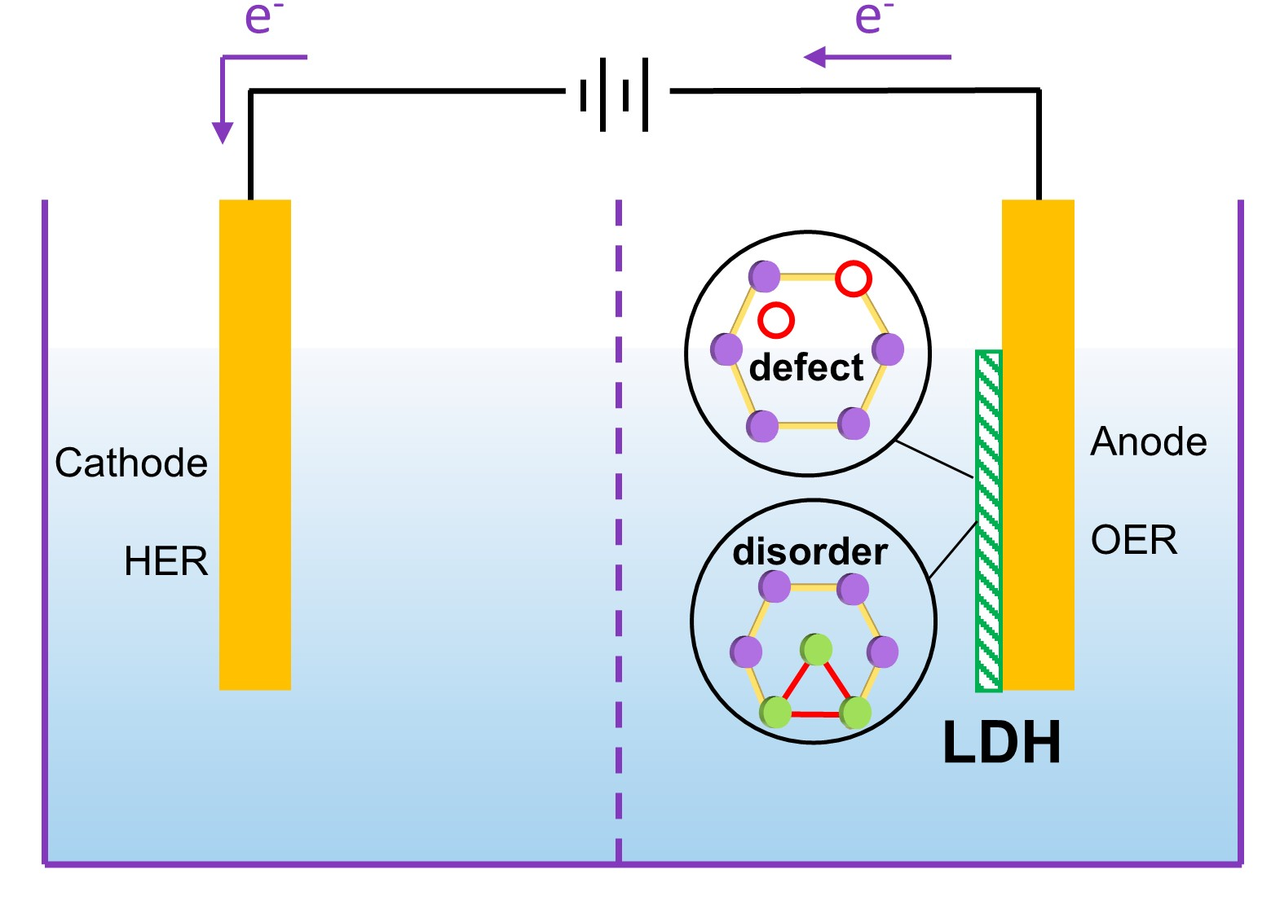
Scheme 1 The effects of defects and disorder on the oxygen evolution reaction using layered double hydroxide electrocatalyst.

Results and discussion
The terms P, V_{O}, V_{Ni} and V_{Al} are used to define, pristine, O defective, Ni defective and Al defective surfaces in LDH structure, respectively (Fig. 1a), different Al³⁺ linkage configurations are shown in Fig. 1b. Moreover, all surface models in this paper were shown in Fig. S1-S4 for clarity. The comparison of surface energy can reflect the stability of the laminated structure³⁸, in order to study the influence of defects and disorder on the stability of laminates, we first compared the energies of all these surfaces. One should notice that the defect formation energy must be took into consideration while comparing the energies. The formation energy of O, Ni and Al defects on the LDH surfaces is performed by the following equation:
P-Al_{m-n} – O = V_{O}-Al_{m-n} (1)
ΔE = E_{VO-Alm-n} + E_{O} – E_{P-Alm-n} (2)
P-Al_{m-n} – Ni = V_{Ni}-Al_{m-n} (3)
ΔE = E_{VNi-Alm-n} + E_{Ni} – E_{P-Alm-n} (4)
P-Al_{m-n} – Al = V_{Al}-Al_{m-n} (5)
ΔE = E_{VAl-Alm-n} + E_{Al} – E_{P-Alm-n} (6)
Where m stands for the number of Al³⁺ cations involved in the disorder linkage and n stands for the different Al³⁺ cation linkage configuration.
The energy comparisons for all these surfaces were listed in Table S1 and the representative models were presented in Fig. 1c. From Fig.1c, it can conclude that O vacancies are easier to form than the metal vacancies on disorder-free surfaces, for the formation energy of O vacancy is negative (–0.54 eV for V_{O}-Al₁₋₁), while the single Ni²⁺ vacancy and Al³⁺ vacancy of LDH structure have large formation energy (5.58 eV for V_{Ni}-Al₁₋₁ and 4.52 eV for V_{Al}-Al₁₋₁), manufacturing metal defects often requires additional special treatment experimentally, such as exfoliation, etching and intercalation, et al. ^{17, 18, 39, 40}. Moreover, about energy changes brought by disorder, on the P surfaces (surfaces without any defects, red line in Fig. 1c), the surface energy increases gradually form Al₁ (no cation disorder) to Al₄ (four Al atom linkage disorder), which means as the number of Al atoms linked to each other by the hydroxyl group increases, the energy of the laminate increases, resulting in instability of the structure. On the V_{O} (blue line in Fig. 1c) surfaces, the surface energy decreases gradually from Al₁ to Al₄, which proves that the presence of disorder on the O defect surface increases the stability of the laminate. While on the V_{Ni} surfaces (green line in Fig. 1c), the surface energy first increases and then decreases form Al₁ to Al₄, but the energy increases in a small range (0.11 eV for V_{Ni}-Al₂₋₁ comparing with V_{Ni}-Al₁₋₁), which is similar with V_{Al} surfaces, energy changes of V_{Al} surfaces show a slight volcanic pattern (The energy peak increased by 0.21 eV for V_{Al}-Al₂₋₁ surface). Such low energy fluctuation implies disorder does not significantly alter the energy of the V_{Ni} and V_{Al} surfaces, therefore on LDH laminates with metal defects, trivalent cation disorder is highly likely to exist. In summary, on the pristine surfaces, the presence of disorder leads to an increase in surface energy, while the presence of disorder on the surface of O defects leads to a decrease in surface energy, and the presence of disorder on the surface of metal defects has a slight impact on energy, defects and disorder may coexist in LDH materials. Furthermore, in order to more accurately simulate the situation in which oxygen and metal defects always coexist in the experiment,¹⁸ we calculated the effect on the surface energy when the two kinds of defects co-exist (V_{O}-V_{Ni} and V_{O}-V_{Al}), a detailed model of the surface construction and energy comparisons were shown in Fig. S5. From Fig. S5c, the energy of the model where the two defects coexist is lower, and on the surface where the two defects coexist, Al-O-Al disorder is also quite likely (Fig. S5d and e). After discussing the effects of defects and disorder on surfaces energy, we will discuss the influence of the coexistence on OER process.

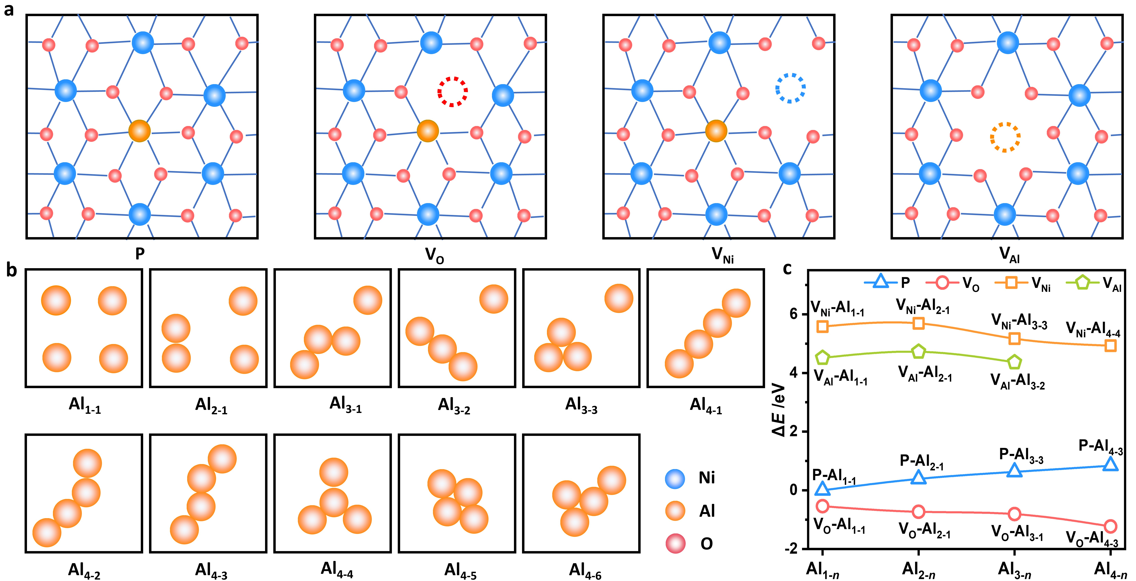
Fig. 1 Schematic illustration of the (a) Pristine, O defect, Ni defect and Al defect surfaces models and (b) disorder models; the blue circles represent the Ni atoms, yellow circles represent the Al atoms and red circles represent the O atoms; the surfaces was named Al_{m-n}, while m stands for the number of Al atoms involved in the disorder linkage and n stands for the different Al cation linkage configuration; (c) Energy comparation between different surfaces.

After investigating the influence of defects and disorder on surface energy, we focused on the overall OER process, and structure diagrams of the complete OER process are shown in Fig. S6. A large number of previous reports have shown that choosing metal ions as active sites to catalyze the OER reaction will cause deformation of the laminate, because the metal ions are deeply encapsulated by the six hydroxyl groups,⁴¹ so we selected the three-coordinated O atom on the LDH laminate as active sites to catalyze the entire OER. We first investigated the coordination environment of O active sites, as shown in Fig. S7a, every O atom was bonded with two Ni²⁺ cations and one Al³⁺ cation (define as Ni₂Al₁). While on the model of disorder, there might be four different types of O atoms with differing coordination environments (Fig. 2a, define as Ni₃, Ni₂Al₁, Ni₁Al₂ and Al₃). To investigate the effect of O coordination environment on OH* adsorption in the first step of OER reaction, we compared the adsorption energy of intermediate OH* at different O active sites, the results are shown in Table S2-S5. The coordination environment of O atoms affects the OH adsorption, which means that the change of the coordination environment of O atoms by disorder significantly affects the initial phase of the OER reaction.
We began by investigating the effect of disorder on the electronic structure of the laminates and the adsorption of intermediates on the P-Al₃₋₃ surface. From the structures (Fig. S1), this surface contains all four types of reactive O sites (Fig. 2a). The Bader charge is frequently employed to investigate charge buildup on the target atom in order to represent the impact of its surrounding coordination environment and has been wildly used in various chemical environments.^{42, 43} The Bader charges of four different reactive O sites was calculated, and the results were shown in Fig. 2b. The higher the Bader charges, the greater the charge accumulation of the target atoms. By studying Bader charge, we find that as the number of Al atoms surrounding O active site rises, ie. as the degree of disorder in Al-O-Al increases, so does the Bader charge of O atom. The presence of disorder promotes the charge accumulation of O active site surrounded by Al atoms. The investigation of the adsorption energy of OH* reveals that the charge accumulation on O atoms must be at an appropriate level to aid OH* adsorption (Fig. 2c). Too high or too low Bader charge will impede the adsorption energy of OH*. Similar research can be also found in 2D material adsorption.⁴⁴
Fig. 2 (a) Four kinds of O active site based on the coordination environment on x-Al₃₋₃ surface under the existence of disorder, x stands for the pristine and defective configuration The Bader charges of different kinds of O active sites (b) and relationship between the adsorption energy of OH* and the Bader charges (c) on P-Al₃₋₃ surface; The Bader charges of different kinds of O active sites (d) and relationship between the adsorption energy of OH* and the Bader charges (e) on V_{O}-Al₃₋₃ surface; The Bader charges of different kinds of O active sites (f) and relationship between the adsorption energy of OH* and the Bader charges (g) on V_{Ni}-Al₃₋₃ surface; The Bader charges of different kinds of O active sites (h) and relationship between the adsorption energy of OH* and the Bader charges (i) on VAl-Al₃₋₃ surface.

On the surfaces of V_{O}-Al₃₋₃, V_{Ni}-Al₃₋₃, and V_{Al}-Al₃₋₃, the effects of this disorder on the electronic structure of active O site and the adsorption of OH* intermediates are shown in Fig. 2d-f. According to the analysis of Fig. 2d-f, the change of O atom Bader charge with disorder on the surface of O, Ni, and Al defects is consistent with the pristine surface, that is, the enhancement of trivalent metal linkage around O atom promotes charge accumulation on O atom, giving the gradually rising Bader charge. Furthermore, charge accumulation on the surface of V_{O}-Al₃₋₃ and V_{Ni}-Al₃₋₃ must be in a reasonable range to promote intermediate adsorption (Fig. 2g and h), whereas charge accumulation on the surface of V_{Al}-Al₃₋₃ gradually increases the difficulty of intermediate adsorption (Fig. 2i), indicating unfavorable OER performance as discussed below. From the results and discussion of the above theoretical results and discussions, the aggregation of Al atoms near the O reaction site affects the adsorption of intermediates by influencing the aggregation of electrons at the O active site, and the aggregation must be maintained at a reasonable level to reduce the adsorption energy of OH.
After investigating the effects of defects and disorder on the electronic structure of the active site, we calculated the energetics of the entire OER process to determine the effects of defects and disorder. The specific energy changes of all 29 selected surfaces are shown in Fig. S8-S11.We have summarized the energy barriers in Fig. 3a to examine the impact of disorder more intuitively on the energy barrier of the OER process (for more information, see Table S6). As shown in Fig. 3a, on the pristine surface without any defect (blue bar), the existence of disorder makes the η_{OER} rise first (0.71 eV for P-Al₁₋₁ and 1.09 eV for P-Al₂₋₁) and then decrease (1.09 eV for P-Al₂₋₁, 0.68 eV for P-Al₃₋₂ and 0.59 eV for P-Al₄₋₄), which means disorder can promote the OER reaction although the structure formation is not favorable (Fig. 1c). A summary of the reaction barriers for OER on the O defect surfaces were shown in Fig. 3a (red bar). Through an analysis of the overpotential in the reaction process, it can be found that the η_{OER} increases first (0.47 eV for V_{O}-Al₁₋₁ and 0.85 eV for V_{O}-Al₂₋₁) and then decreases (0.85 eV for V_{O}-Al₂₋₁, 0.39 eV for V_{O}-Al₃₋₁ and 0.51 eV for V_{O}-Al₄₋₄). The lower OER barrier indicates that disorder promotes the OER reaction on the surface of O vacancy. The potential determining step (pds) is the elementary step with the most positive Gibbs reaction free energy, the pds and associated thermodynamic overpotential are readily identified from the free energy profile calculated ⁴⁵⁻⁴⁷. There are two types of potential determining steps in all OER reaction processes: OH* → O* and O* → OOH* (Fig. S9), which means on the O defect surface, the existence of disorder would influence the breakage of O-H bonds and formation of O-O bonds.
Further, we consider the effect of disorder in addition to Ni defects on the LDH surfaces toward OER performance. A summary of reaction barriers for OER on Ni defective surfaces is shown in Fig. 3a (orange bar). With the addition of disorder, the η_{OER} shows a volcano-type response (0.67 eV for V_{Ni}-Al₁₋₁, 0.78 eV for V_{Ni}-Al₂₋₁ and 0.49 eV for V_{Ni}-Al₃₋₁). Comparing with the V_{Ni}-Al₁₋₁ surface, the lower OER barrier in the V_{Ni}-Al₃₋₁ (0.49 eV), V_{Ni}-Al₃₋₂ (0.55 eV) and V_{Ni}-Al₄₋₃ (0.66 eV) surfaces indicates that the existence of disorder promotes the OER reaction on Ni defective surfaces. There are two types of potential determining steps in all OER reaction processes on Ni defective surfaces: H₂O* → OH* and O* → OOH* (Fig. S10), which means the existence of disorder would influence the adsorption of OH* intermediates and the formation of O-O bonds that promote the OER performance. As shown in Fig. 3a, on Al defective surfaces (green bar), the existence of disorder hinders the OER reaction (η_{OER} is 0.35 eV for V_{Al}-Al₁₋₁, 1.07 eV for V_{Al}-Al₂₋₁ and 0.61 eV for V_{Al}-Al₃₋₂). The existence of disorder significantly changed the OER reaction potential determining steps from O-H cleavage to the adsorption of OH and the formation of O-O bond (Fig. S11).
Subsequently, taking the P-Al₁₋₁, P-Al₄₋₄, V_{O}-Al₁₋₁, V_{O}-Al₃₋₁, V_{Ni}-Al₁₋₁, V_{Ni}-Al₃₋₁, V_{Al}-Al₁₋₁ and V_{Al}-Al₃₋₂ surfaces as representative samples, detailed free energy diagrams are shown in Fig. 3b-i. P-Al₁₋₁ model represents the pristine surface without any defects or disorder, and the η_{OER} is 0.71 eV (Fig. 3b), while the overpotential decreases to 0.59 eV on the P-Al₄₋₄ surface where disorder is introduced (Fig. 3c). This shows that the introduction of disorder can reduce the overpotential energy barrier, but it is not as significant as the effect of defects on the improvement of catalytic performance since the η_{OER} of V_{O}-Al₁₋₁ and V_{Al}-Al₁₋₁ is 0.47 eV and 0.35 eV, respectively^{48, 49}. In addition, the experimental results indicate that the overpotential of NiAl-LDH material with Al defects catalyzing OER reaction is 0.31V³⁶, matching our calculated results, proving the accuracy of the calculated results. It can also be seen from Fig. 3b-g that the introduction of disorder can reduce the OER overpotential on the pristine, O defect and Ni defect surfaces. According to the analysis of the overpotential energy, the existence of defects dominates energetics of the reaction, and disorder has a slight promotion effect. Special experimental treatments, such as exfoliation¹⁷, etching¹⁸, and intercalation³⁹, et al., can introduce a large number of oxygen and metal defects on LDHs laminates. The research results confirm that the presence of defects promotes substrate adsorption and electron transfer, thus greatly improving the catalytic performance of LDHs in OER reactions^{48, 49}.

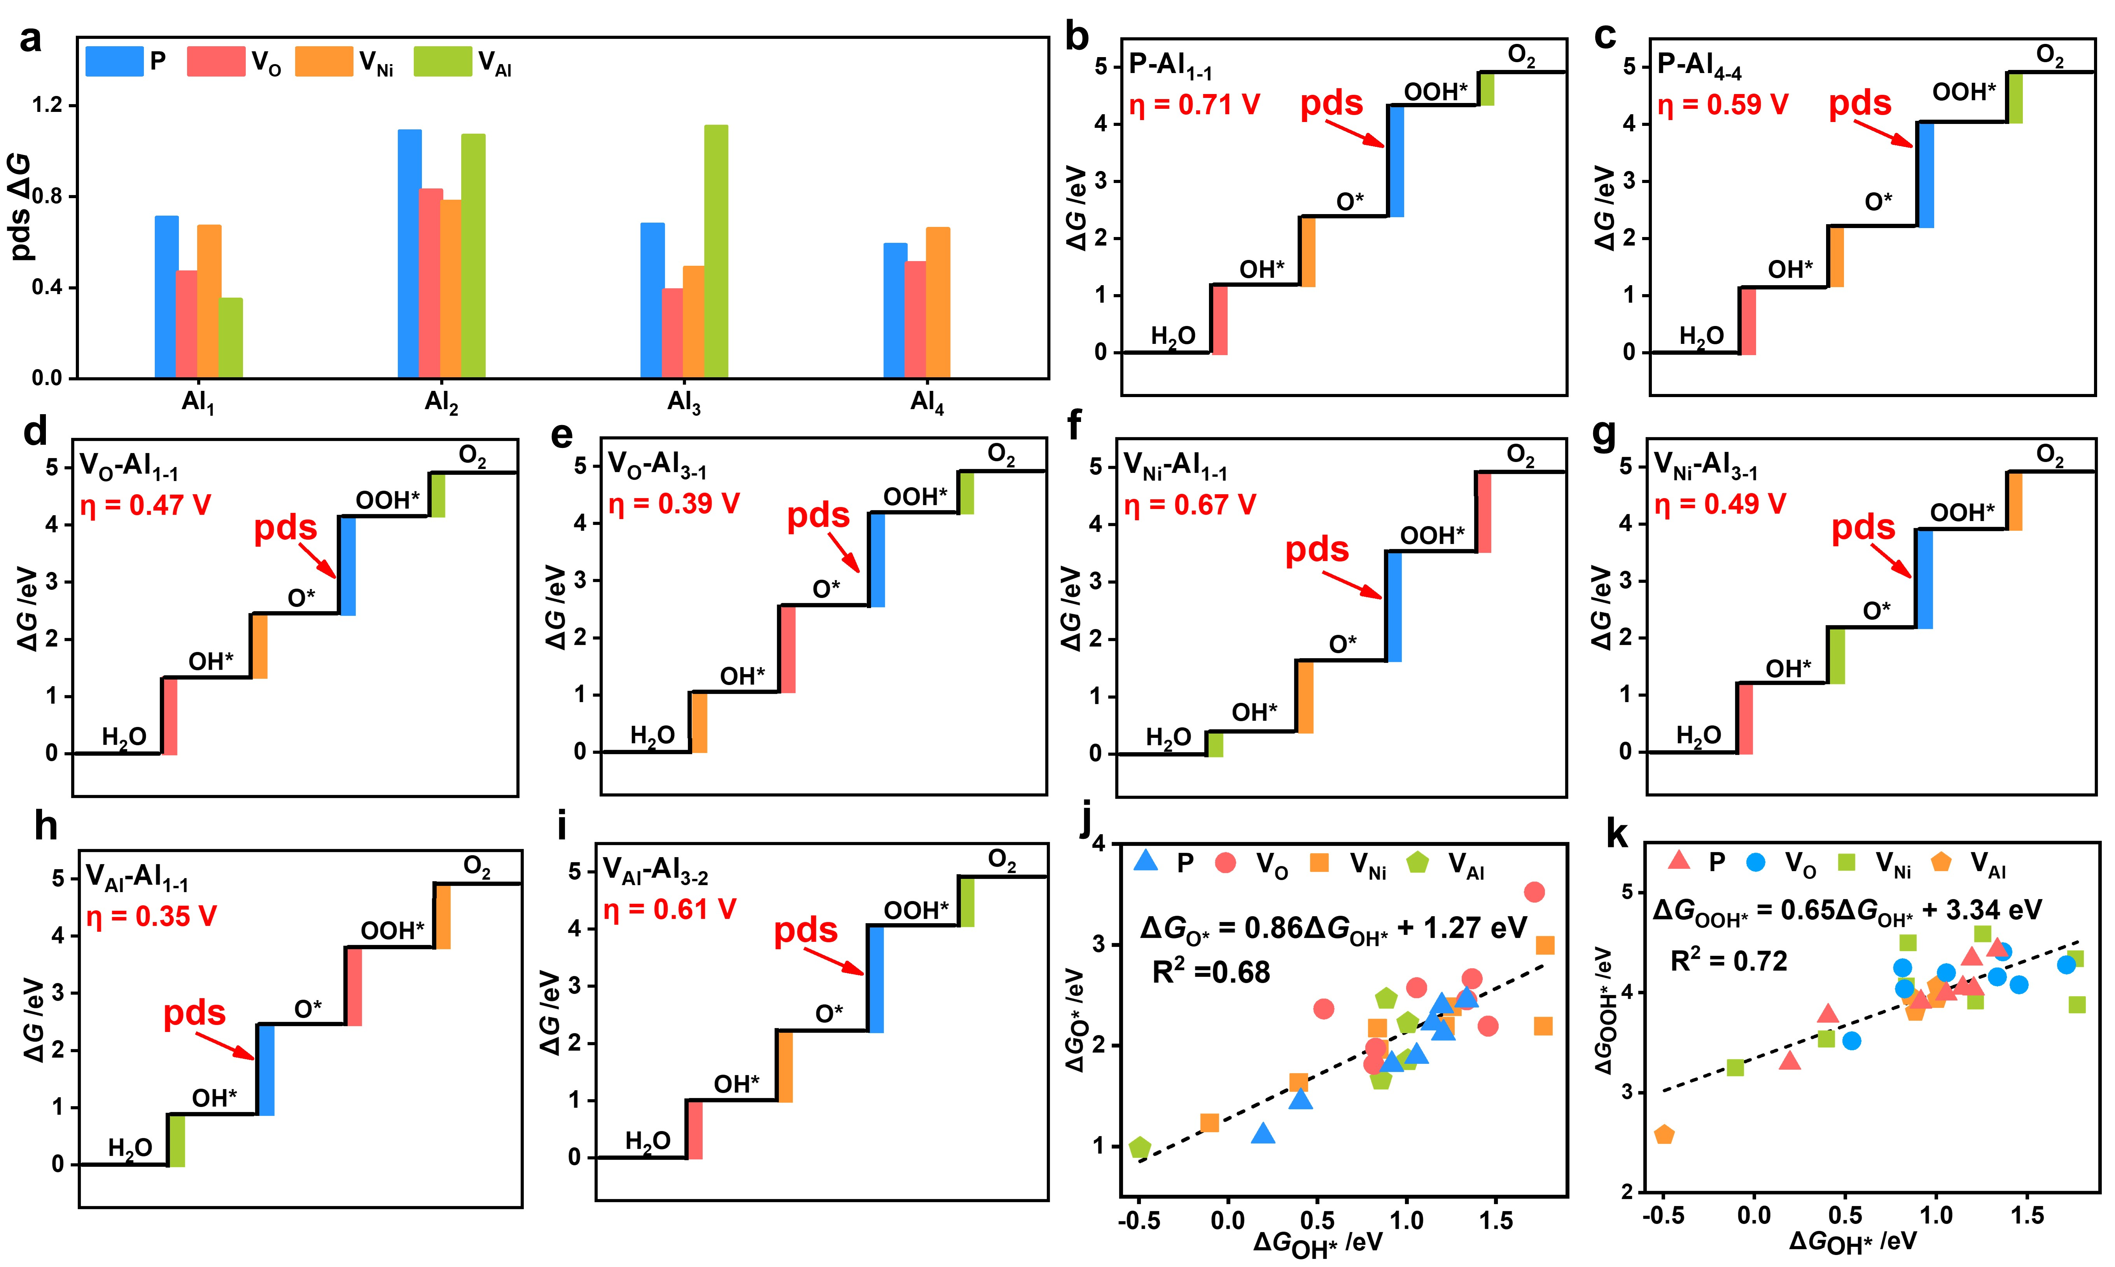
Fig. 3 (a) Reaction barriers of OER process on pristine surfaces (blue), O defect surfaces (red), Ni defect surfaces (orange) and Al defect surfaces (green). Detailed free energy diagrams for (b) P-Al₁₋₁, (c) P-Al₄₋₄, (d) V_{O}-Al₁₋₁, (e) V_{O}-Al₃₋₁, (f) V_{Ni}-Al₁₋₁, (g) V_{Ni}-Al₃₋₁, (h) V_{Al}-Al₁₋₁ and (i) V_{Al}-Al₃₋₂ surfaces. (i) Contour plot of OER activity for the defective and disordered surfaces. The scaling relationship between (j) ΔG_{O*} vs. ΔG_{OH*} and (k) ΔG_{OOH*} vs. ΔG_{OH*} for different surfaces.

Fig. 3j-k depicts the scaling relationship of ΔG_{O*} vs. ΔG_{OH*} and ΔG_{OOH*} vs. ΔG_{OH*}. As seen in Fig. 3j, Gibbs free energy of adsorbed O* and OOH* follows a linear relationship, which is ΔG_{O*} = 0.86ΔG_{OH*} + 1.27 eV, and Gibbs free energy of adsorbed OH* and OOH* follows a strong linear relationship, which is ΔG_{OOH*} = 0.65ΔG_{OH*} + 3.34 eV (Fig. 3k), as represented by the black dashed line.
The full OER reaction Gibbs free energy of eqn. (9) (supporting information) may be stated as follows based on the scaling relation:
ΔG₁ = ΔG_{OH*} (1)
ΔG₂ = ΔG_{O*} – ΔG_{OH*} (2)
ΔG₃ = (0.65ΔG_{OH*} + 3.34) – ΔG₁- ΔG₂ (3)
ΔG₄ = 4.92 – (ΔG₁ + ΔG₂ + ΔG₃) (4)
Only two independent descriptors were observed in eqn. (1)-(4): ΔG_{OH*} and ΔG_{O*} – ΔG_{OH*}. These two descriptors were used to clearly identify the overall OER performance for a certain electrocatalyst. A two-dimensional volcano plot ^{41, 50-53} based on the two independent descriptors (ΔG_{OH*} and ΔG_{O*} - ΔG_{OH*}) was used to display the limiting overpotentials as shown in Fig. 4. The contour map divides into four zones based on the difference of Gibbs free energy (white dashed lines). Most of the data points are in third zone, which indicated that the potential determining step⁴⁵⁻⁴⁷ (pds) of OER reaction on most surfaces is the O*→OOH* step. The golden area of the plot displays a region of greater OER performance than the purple area, optimal catalytic activities converge at the end point of the white dashed line under the condition of ΔG₁ = ΔG₂ = ΔG₃. This contour map predicts of potential determining steps for all models are in good accord with the Gibbs free energy results in Fig. 3a.
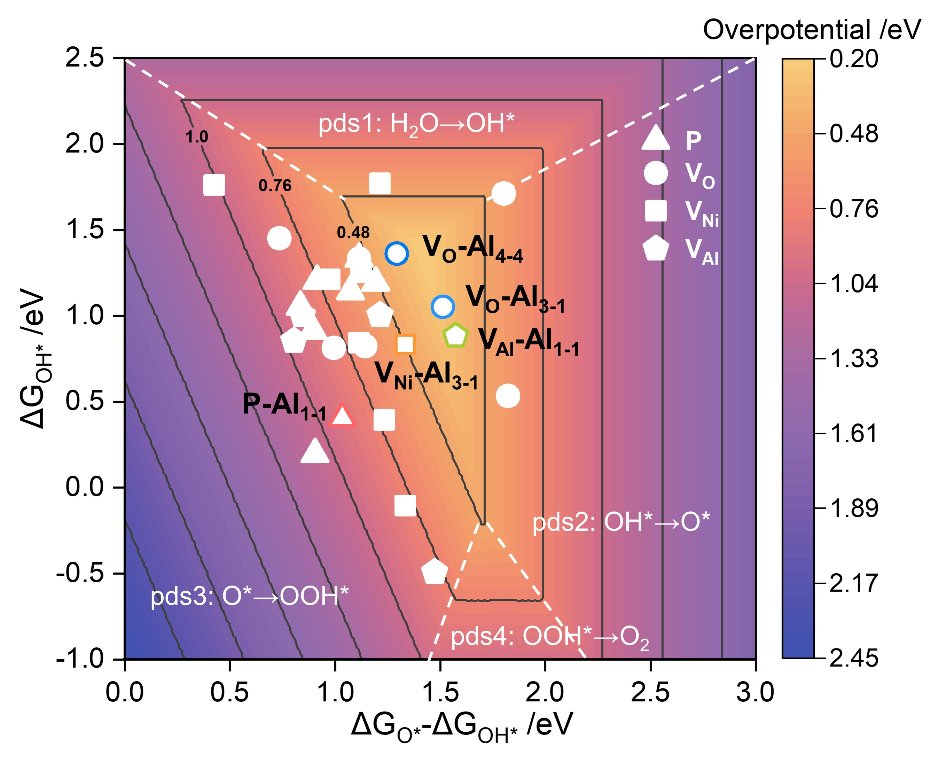
Fig. 4 Contour plot of OER activity for the defective and disordered surfaces
To explore in more depth the impact of defects and disorder on the OER process, the electronic structure for some of the selected surfaces was calculated. Four surfaces (P-Al₁₋₁, P-Al₂₋₁, P-Al₃₋₂ and P-Al₄₋₁) were selected, and their total densities of states (TDOS) and partial density of states (PDOS) were determined (Fig. S12). These surfaces correspond to the lowest η_{OER} at pristine surfaces. It can be seen from the analysis of DOS diagram that the PDOS of Ni and PDOS of O play a major role in the construction of electronic structure of pristine surfaces. To find a suitable electronic structure descriptor to further explain the OER energy barrier change pattern, we first calculated the d-band center of Ni atoms. As shown in Fig. S13, disorder influences the d-band centers of Ni atoms on the pristine surfaces. However, the regularity of the d-band center of Ni atoms did not correspond well with the η_{OER} of pristine surfaces. We calculated the p-band center of O atoms, and the results were shown in Fig. 5a. The calculated results suggest that the η_{OER} is consistent with the p-band center of O atoms on pristine surfaces, ie., the farther the p-band center of O atoms lies away from the Fermi level, the higher the corresponding overpotential of OER reaction. The decline of O p-band center is unfavorable to the adsorption of intermediate species.
In addition, we also calculated the DOS of the O defects surface (Fig. S14) and the corresponding d-band centers of Ni atoms (Fig. S15). The analysis of DOS diagram reveals that the PDOS of Ni and PDOS of O are crucial in the development of the electronic structure of O defect surfaces. As shown in Fig. S15, the d-band center of Ni atoms on the O defect surfaces is consistent with the OER energy barrier, that is, the lowering of the d-band center raises the energy barrier for the OER reaction, which is different from the pristine surface. The trend observed for the p-band center (Fig. 5b) is consistent with that observed for the d-band center, ie., the distance between these band centers and the Fermi level hinders the OER reaction. Thus, the d-band center and the p-band center can be used as descriptors of the O defect surfaces.
The electronic structure calculations were also performed for Ni defective and Al defective surfaces. The PDOS of Ni and PDOS of O play a major role in the construction of electronic structure of pristine surfaces (Fig. S16 for Ni defective surfaces and Fig. S18 for Al defective surfaces) and the regularity of the d-band center of Ni is not consistent with the OER reaction energy barrier (Fig. S17 for Ni defective surfaces and Fig. S19 for Al defective surfaces). The charge transfer energy^{54, 55} was also calculated to further investigate the relationship between electronic structure and catalytic performance, detailed description was shown in Fig. S20. However, as shown in Fig. 5c and d, the calculated results suggest that the η_{OER} is consistent with the p-band center of O atoms on Ni defect surfaces while consistency is not exhibited on the Al defect surface.
In summary, both the defects and disorder joint influence the OER reaction, this originates from affecting the O p-band center. It is conceivable that the aggregation of Al influences the electronegativity of the nearby O active site since Al is more electronegative, which influences the electronic density and further influences the p-band centers. The p-band center of oxygen can be modulated in future designs for LDHs materials to improve OER performance.
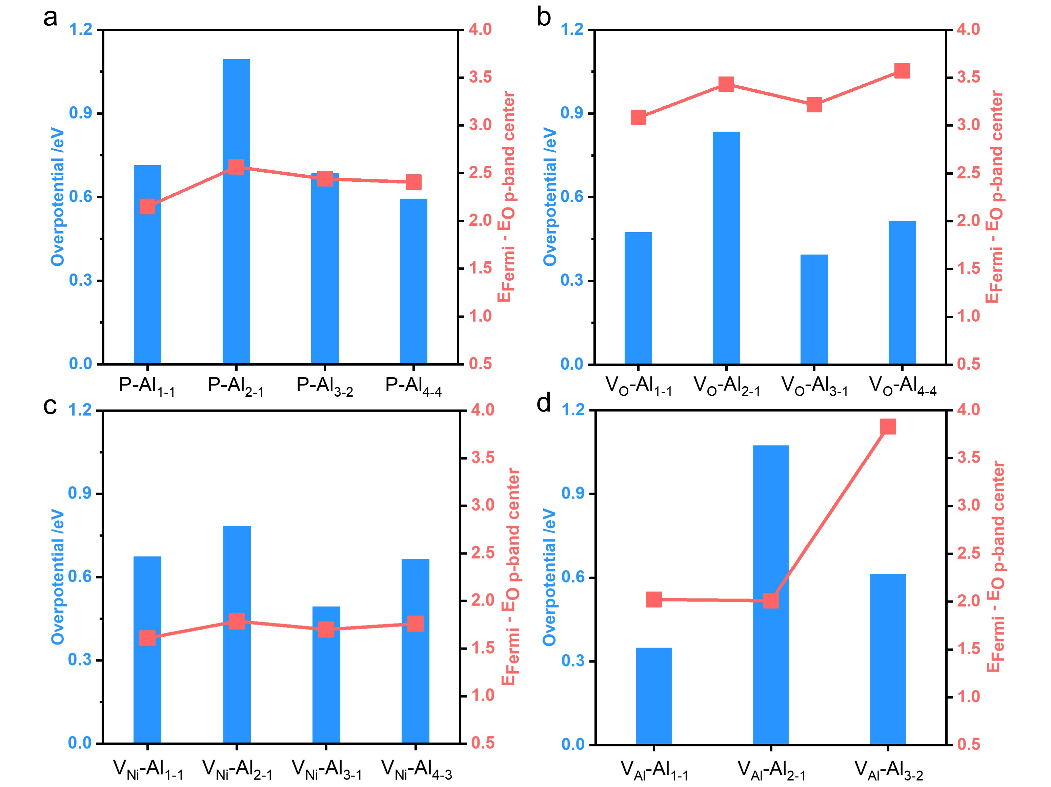
Fig. 5 The η_{OER} and the p-band center of O atoms of the (a) pristine surfaces; (b) O defect surfaces; (c) Ni defect surfaces and (d) Al defect surfaces. The selected disordered surface corresponds to the surface with the lowest η_{OER} under the corresponding degree of disorder.

Conclusion
In summary, a series of Ni₂Al-LDH electrocatalyst models were constructed in the present work, and their OER performance was systematically calculated via DFT calculations to investigate the influence caused by the defects and disorder. The surface energy indicates that disorder can coexist with oxygen/metal defects to ensure the stability of the material. The cation disorder affects the accumulation of charge on the surrounding O active sites, which affects the adsorption of the first intermediate OH in the OER process, therefore affects the entire OER process. Moreover, even if defects play a dominant role in the promotion of OER process, disorder can also promote the occurrence of OER reaction. Electronic structure calculations show that the presence of defects and disorder significantly affects the p-band centers of O atoms on the matrix, which is responsible for the increased OER activity. Our results not only pave a new way for revealing the interaction between defects and disorder but can also be extended as theoretical guidelines to develop other LDHs materials with superior electrocatalytic performance.

Supporting Information Statement: The details of computational method and model construction are given, along with illustrations of the reaction surfaces models, reaction free energies, and electronic structures.

Acknowledgments:
This research was supported by the National Natural Science Foundation of China (22278030, 22090032, 22090030, 22288102), the Fundamental Research Funds for the Central Universities (buctrc202119, 2312018RC07), Major Program of Qingyuan Innovation Laboratory (Grant No. 001220005).

References
(1) Xu, H.; Yuan, J.; He, G.; Chen, H. Current and future trends for spinel-type electrocatalysts in electrocatalytic oxygen evolution reaction. Coord. Chem. Rev. 2023, 475, 214869.
(2) Suntivich, J.; May, K. J.; Gasteiger, H. A.; Goodenough, J. B.; Shao-Horn, Y. A Perovskite Oxide Optimized for Oxygen Evolution Catalysis from Molecular Orbital Principles. Science 2011, 334 (6061), 1383-1385.
(3) Campbell, C. T. Electronic perturbations. Nat. Chem. 2012, 4 (8), 597-598.
(4) Huang, C.; Zhou, J.; Duan, D.; Zhou, Q.; Wang, J.; Peng, B.; Yu, L.; Yu, Y. Roles of heteroatoms in electrocatalysts for alkaline water splitting: A review focusing on the reaction mechanism. Chin. J. Catal. 2022, 43 (8), 2091-2110.
(5) Xiao, M.; Zhang, C.; Wang, P.; Zeng, W.; Zhu, J.; Li, Y.; Peng, W.; Liu, Q.; Xu, H.; Zhao, Y.; et al. Polymetallic phosphides evolved from MOF and LDH dual-precursors for robust oxygen evolution reaction in alkaline and seawater media. Mater. Today Phys. 2022, 24, 100684.
(6) Hegner, F. S.; Galán-Mascarós, J. R.; López, N. Lowering the Water Oxidation Overpotential by Spin-Crossover in Cobalt Hexacyanoferrate. J. Phys. Chem. Lett. 2022, 13 (18), 4104-4110.
(7) Xu, X.; Song, F.; Hu, X. A nickel iron diselenide-derived efficient oxygen-evolution catalyst. Nat. Commun. 2016, 7 (1), 12324.
(8) Joo, J.; Kim, T.; Lee, J.; Choi, S.-I.; Lee, K. Morphology-Controlled Metal Sulfides and Phosphides for Electrochemical Water Splitting. Adv. Mater. 2019, 31 (14), 1806682.
(9) Guo, Y.; Park, T.; Yi, J. W.; Henzie, J.; Kim, J.; Wang, Z.; Jiang, B.; Bando, Y.; Sugahara, Y.; Tang, J.; et al. Nanoarchitectonics for Transition-Metal-Sulfide-Based Electrocatalysts for Water Splitting. Adv. Mater. 2019, 31 (17), 1807134.
(10) Zhang, Y.; Ouyang, B.; Xu, J.; Jia, G.; Chen, S.; Rawat, R. S.; Fan, H. J. Rapid Synthesis of Cobalt Nitride Nanowires: Highly Efficient and Low-Cost Catalysts for Oxygen Evolution. Angew. Chem. Int. Ed. Engl. 2016, 55 (30), 8670-8674.
(11) Broicher, C.; Zeng, F.; Artz, J.; Hartmann, H.; Besmehn, A.; Palkovits, S.; Palkovits, R. Facile Synthesis of Mesoporous Nickel Cobalt Oxide for OER – Insight into Intrinsic Electrocatalytic Activity. ChemCatChem 2019, 11 (1), 412-416.
(12) Shin, H.; Xiao, H.; Goddard, W. A., III. In Silico Discovery of New Dopants for Fe-Doped Ni Oxyhydroxide (Ni1–xFexOOH) Catalysts for Oxygen Evolution Reaction. J. Am. Chem. Soc. 2018, 140 (22), 6745-6748.
(13) Gao, Z.-W.; Liu, J.-Y.; Chen, X.-M.; Zheng, X.-L.; Mao, J.; Liu, H.; Ma, T.; Li, L.; Wang, W.-C.; Du, X.-W. Engineering NiO/NiFe LDH Intersection to Bypass Scaling Relationship for Oxygen Evolution Reaction via Dynamic Tridimensional Adsorption of Intermediates. Adv. Mater. 2019, 31 (11), 1804769.
(14) Ye, S. H.; Shi, Z. X.; Feng, J. X.; Tong, Y. X.; Li, G. R. Activating CoOOH Porous Nanosheet Arrays by Partial Iron Substitution for Efficient Oxygen Evolution Reaction. Angew. Chem. Int. Ed. Engl. 2018, 57 (10), 2672-2676.
(15) Seong, J.-G.; Ko, T. H.; Lei, D.; Choi, W.-K.; Kuk, Y.-S.; Seo, M.-K.; Kim, B.-S. Engineered NiCo-LDH nanosheets- and ZnFe2O4 nanocubes-decorated carbon nanofiber bonded mats for high-rate asymmetric supercapacitors. Green Energy. Environ. 2022, 7 (6), 1228-1240.
(16) Du, H.; Fan, J.; Miao, C.; Gao, M.; Liu, Y.; Li, D.; Feng, J. Recent Advances in Constructing Interfacial Active Catalysts Based on Layered Double Hydroxides and Their Catalytic Mechanisms. Trans. Tianjin Univ. 2021, 27 (1), 24-41.
(17) Liu, R.; Wang, Y.; Liu, D.; Zou, Y.; Wang, S. Water-Plasma-Enabled Exfoliation of Ultrathin Layered Double Hydroxide Nanosheets with Multivacancies for Water Oxidation. Adv. Mater. 2017, 29 (30),
(18) Xie, Q.; Cai, Z.; Li, P.; Zhou, D.; Bi, Y.; Xiong, X.; Hu, E.; Li, Y.; Kuang, Y.; Sun, X. Layered double hydroxides with atomic-scale defects for superior electrocatalysis. Nano Res. 2018, 11 (9), 4524-4534.
(19) Zhao, Y.; Zhang, X.; Jia, X.; Waterhouse, G. I. N.; Shi, R.; Zhang, X.; Zhan, F.; Tao, Y.; Wu, L.-Z.; Tung, C.-H.; et al. Sub-3 nm Ultrafine Monolayer Layered Double Hydroxide Nanosheets for Electrochemical Water Oxidation. Adv. Energy Mater. 2018, 8 (18), 1703585.
(20) Liu, W.; Kamiko, M.; Yamada, I.; Yagi, S. Effects of cation vacancies at tetrahedral sites in cobalt spinel oxides on oxygen evolution catalysis. Mater. Adv. 2022, 3 (20), 7513-7519.
(21) Hirai, S.; Morita, K.; Yasuoka, K.; Shibuya, T.; Tojo, Y.; Kamihara, Y.; Miura, A.; Suzuki, H.; Ohno, T.; Matsuda, T.; et al. Oxygen vacancy-originated highly active electrocatalysts for the oxygen evolution reaction. J. Mater. Chem. A 2018, 6 (31), 15102-15109.
(22) Zhao, Y.; Zhao, Y.; Waterhouse, G. I. N.; Zheng, L.; Cao, X.; Teng, F.; Wu, L.-Z.; Tung, C.-H.; O'Hare, D.; Zhang, T. Layered-Double-Hydroxide Nanosheets as Efficient Visible-Light-Driven Photocatalysts for Dinitrogen Fixation. Adv. Mater. 2017, 29 (42), 1703828.
(23) Li, Z.; Mao, C.; Pei, Q.; Duchesne, P. N.; He, T.; Xia, M.; Wang, J.; Wang, L.; Song, R.; Ali, F. M.; et al. Engineered disorder in CO2 photocatalysis. Nat. Commun. 2022, 13 (1), 7205.
(24) Seijas-Da Silva, A.; Oestreicher, V.; Coronado, E.; Abellan, G. Influence of Fe-clustering on the water oxidation performance of two-dimensional layered double hydroxides. Dalton Trans. 2022, 51 (12), 4675-4684.
(25) Sideris, P. J.; Nielsen, U. G.; Gan, Z.; Grey, C. P. Mg/Al ordering in layered double hydroxides revealed by multinuclear NMR spectroscopy. Science 2008, 321 (5885), 113-117.
(26) Yan, H.; Wei, M.; Ma, J.; Evans, D. G.; Duan, X. Plane-Wave Density Functional Theory Study on the Structural and Energetic Properties of Cation-Disordered Mg−Al Layered Double Hydroxides. J. Phys. Chem. A 2010, 114 (27), 7369-7376.
(27) Cadars, S.; Layrac, G.; Gérardin, C.; Deschamps, M.; Yates, J. R.; Tichit, D.; Massiot, D. Identification and Quantification of Defects in the Cation Ordering in Mg/Al Layered Double Hydroxides. Chem. Mater. 2011, 23 (11), 2821-2831.
(28) Funnell, N. P.; Wang, Q.; Connor, L.; Tucker, M. G.; O'Hare, D.; Goodwin, A. L. Structural characterisation of a layered double hydroxide nanosheet. Nanoscale 2014, 6 (14), 8032-8036.
(29) Jin, L.; Zhou, X.; Wang, F.; Ning, X.; Wen, Y.; Song, B.; Yang, C.; Wu, D.; Ke, X.; Peng, L. Insights into memory effect mechanisms of layered double hydroxides with solid-state NMR spectroscopy. Nat. Commun. 2022, 13 (1), 6093.
(30) Roy Chowdhury, P.; Medhi, H.; Bhattacharyya, K. G.; Mustansar Hussain, C. Recent progress in the design and functionalization strategies of transition metal-based layered double hydroxides for enhanced oxygen evolution reaction: A critical review. Coord. Chem. Rev. 2023, 483, 215083.
(31) Feng, Y.; Ma, R.; Wang, M.; Wang, J.; Sun, T.; Hu, L.; Zhu, J.; Tang, Y.; Wang, J. Crystallinity Effect of NiFe LDH on the Growth of Pt Nanoparticles and Hydrogen Evolution Performance. J. Phys. Chem. Lett. 2021, 12 (30), 7221-7228.
(32) Chen, J. Y. C.; Dang, L.; Liang, H.; Bi, W.; Gerken, J. B.; Jin, S.; Alp, E. E.; Stahl, S. S. Operando Analysis of NiFe and Fe Oxyhydroxide Electrocatalysts for Water Oxidation: Detection of Fe4+ by Mössbauer Spectroscopy. J. Am. Chem. Soc. 2015, 137 (48), 15090-15093.
(33) Sun, Z.; Lin, L.; He, J.; Ding, D.; Wang, T.; Li, J.; Li, M.; Liu, Y.; Li, Y.; Yuan, M.; et al. Regulating the Spin State of FeIII Enhances the Magnetic Effect of the Molecular Catalysis Mechanism. J. Am. Chem. Soc. 2022, 144 (18), 8204-8213.
(34) Islam, M. S.; Kim, M.; Jin, X.; Oh, S. M.; Lee, N.-S.; Kim, H.; Hwang, S.-J. Bifunctional 2D Superlattice Electrocatalysts of Layered Double Hydroxide–Transition Metal Dichalcogenide Active for Overall Water Splitting. ACS Energy Lett. 2018, 3 (4), 952-960.
(35) Kim, K.-H.; Choi, J. W.; Lee, H.; Moon, B. C.; Park, D. G.; Choi, W. H.; Kang, J. K. Plasma-mediated fabrication of ultrathin NiAl nanosheets having rich oxygen vacancies and doped nitrogen sites and their utilization for high activity and robust stability in photoelectrochemical water oxidation. J. Mater. Chem. A 2018, 6 (46), 23283-23288.
(36) Feng, L.; Du, Y.; Huang, J.; Cao, L.; Feng, L.; Feng, Y.; Liu, Q.; Yang, D.; Kajiyoshi, K. Nanoporous NiAl-LDH nanosheet arrays with optimized Ni active sites for efficient electrocatalytic alkaline water splitting. Sustain. Energy Fuels 2020, 4 (6), 2850-2858.
(37) Wang, T.; Guo, M.; Zhang, X.; Cao, Y.; Wu, Q.; Tu, J.; Zhang, K. Defect-Rich NiFeAl-Layered Double Hydroxide Nanosheets for Efficient Electrocatalytic Oxygen Evolution Reaction. ACS Appl. Nano Mater. 2023, 6 (7), 6002-6010.
(38) Gong, J.; Sun, R.; Cui, L.; Cao, C.; Shi, K.; Zhang, M.; Gao, R.; Hao, H. The Tune Effect of Surface Pt/Mo Ratio on the Stability and Morphology of α-MoC surfaces. Surf. Interfaces 2021, 22, 100831.
(39) Tan, L.; Xu, S.-M.; Wang, Z.; Xu, Y.; Wang, X.; Hao, X.; Bai, S.; Ning, C.; Wang, Y.; Zhang, W.; et al. Highly Selective Photoreduction of CO2 with Suppressing H2 Evolution over Monolayer Layered Double Hydroxide under Irradiation above 600 nm. Angew. Chem., Int. Ed. 2019, 58 (34), 11860-11867.
(40) Song, F.; Hu, X. Exfoliation of layered double hydroxides for enhanced oxygen evolution catalysis. Nat. Commun. 2014, 5 (1), 4477.
(41) Xue, Z.; Zhang, X.; Qin, J.; Liu, R. Revealing Ni-based layered double hydroxides as high-efficiency electrocatalysts for the oxygen evolution reaction: a DFT study. J. Mater. Chem. A 2019, 7 (40), 23091-23097.
(42) Yan, Z.; Cui, L.; Shi, K.; Zhang, M.; Pang, Z.; Guo, J.; Gao, R.; Hao, H. Theoretical study the influence of partial substitute noble metal Pd/Ag of PdAg-based catalyst by non-noble metal Ni/Cu for 1,3-Butadiene hydrogenation. Appl. Surf. Sci. 2022, 588, 152897.
(43) Cui, L.; Shi, K.; Zhang, M.; Guo, J.; Yan, Z.; Hao, H.; Gao, R. Theoretical study the electrocatalytic performance and mechanism of novel designed electrocatalyst Ru@2DMs for CO2RR. Fuel 2023, 340, 127541.
(44) Zhang, J.; Pang, J.; Chen, H.; Wei, G.; Wei, S.; Yan, J.; Jin, S. Study on SO2 and Cl2 sensor application of 2D PbSe based on first principles calculations. RSC Adv. 2022, 12 (14), 8530-8535.
(45) Kozuch, S.; Martin, J. M. L. The Rate-Determining Step is Dead. Long Live the Rate-Determining State! ChemPhysChem 2011, 12 (8), 1413-1418.
(46) Tripkovic, V.; Vegge, T. Potential- and Rate-Determining Step for Oxygen Reduction on Pt(111). J. Phys. Chem. C 2017, 121 (48), 26785-26793.
(47) Huang, J.; Zhu, X.; Eikerling, M. The rate-determining term of electrocatalytic reactions with first-order kinetics. Electrochim. Acta 2021, 393, 139019.
(48) Zhao, Y.; Waterhouse, G. I. N.; Chen, G.; Xiong, X.; Wu, L.-Z.; Tung, C.-H.; Zhang, T. Two-dimensional-related catalytic materials for solar-driven conversion of COx into valuable chemical feedstocks. Chem. Soc. Rev. 2019, 48 (7), 1972-2010.
(49) Zhou, D.; Li, P.; Lin, X.; McKinley, A.; Kuang, Y.; Liu, W.; Lin, W.-F.; Sun, X.; Duan, X. Layered double hydroxide-based electrocatalysts for the oxygen evolution reaction: identification and tailoring of active sites, and superaerophobic nanoarray electrode assembly. Chem. Soc. Rev. 2021, 50 (15), 8790-8817.
(50) Friebel, D.; Louie, M. W.; Bajdich, M.; Sanwald, K. E.; Cai, Y.; Wise, A. M.; Cheng, M. J.; Sokaras, D.; Weng, T. C.; Alonso-Mori, R.; et al. Identification of highly active Fe sites in (Ni,Fe)OOH for electrocatalytic water splitting. J. Am. Chem. Soc. 2015, 137 (3), 1305-1313.
(51) Singh, Y.; Back, S.; Jung, Y. Computational exploration of borophane-supported single transition metal atoms as potential oxygen reduction and evolution electrocatalysts. Phys. Chem. Chem. Phys. 2018, 20 (32), 21095-21104.
(52) Hu, M.; Li, S.; Zheng, S.; Liang, X.; Zheng, J.; Pan, F. Tuning Single-Atom Catalysts of Nitrogen-Coordinated Transition Metals for Optimizing Oxygen Evolution and Reduction Reactions. J. Phys. Chem. C 2020, 124 (24), 13168-13176.
(53) Zhang, L.; Raman, A. S.; Vojvodic, A. Reviving Inert Oxides for Electrochemical Water Splitting by Subsurface Engineering. Chem. Mater. 2020, 32 (13), 5569-5578.
(54) Hong, W. T.; Stoerzinger, K. A.; Lee, Y.-L.; Giordano, L.; Grimaud, A.; Johnson, A. M.; Hwang, J.; Crumlin, E. J.; Yang, W.; Shao-Horn, Y. Charge-transfer-energy-dependent oxygen evolution reaction mechanisms for perovskite oxides. Energy Environ. Sci. 2017, 10 (10), 2190-2200.
(55) Yamada, I.; Takamatsu, A.; Asai, K.; Shirakawa, T.; Ohzuku, H.; Seno, A.; Uchimura, T.; Fujii, H.; Kawaguchi, S.; Wada, K.; et al. Systematic Study of Descriptors for Oxygen Evolution Reaction Catalysis in Perovskite Oxides. J. Phys. Chem. C 2018, 122 (49), 27885-27892.

